Task 1 :

Algorithm   
  
we suppose to detect the length of the biggest crack (the blue line).

Giving : the width of the crack

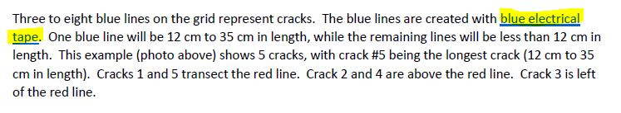  
 

Knowing the width of the crack we can calculate the length  
by calculating two main factor

1. The numb of pixel of the width
2. The numb of pixel of the height

From the pixel numb of the Width we can calculate the true length of the single pixel

And by multiplying it by the numb of the pixel we can get the True length

.

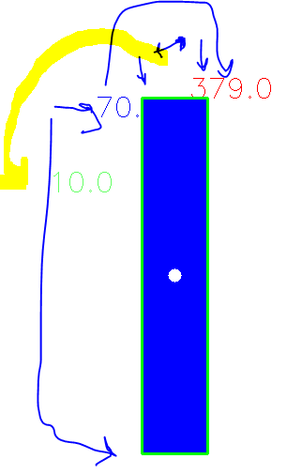

Width_pixel = 70 width_true_lengh = 1.85

Hight_pixel = 379

Hight = (( width_true_lengh / Width_pixel )) * Hight_pixel = ((1.85/70))*379 = 10 cm

Steps to run the code :  
  
Open the folder as Edit with IDLE

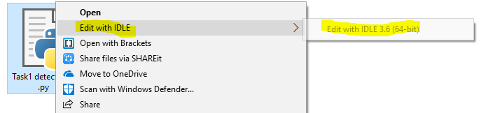

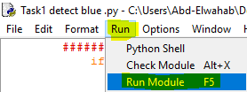

Run > Run module   
OR  
F5

The screen will divide into two   
The Right one where I can control and open the DVR Screen programmer.

The left one is the Screen of the Right one, where any processing is on to.

Just by adjust the blue crake on the DVR camera it will automatically calculate the length and right it on the console and on the Crake frame

